**Assignment 3.2**

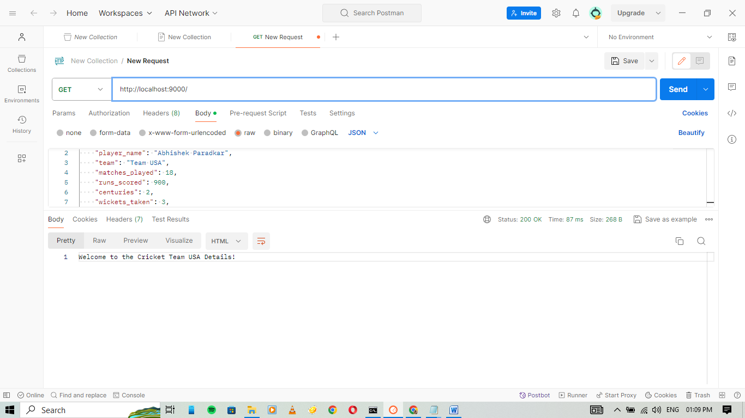

Adding the Cricket Players Details

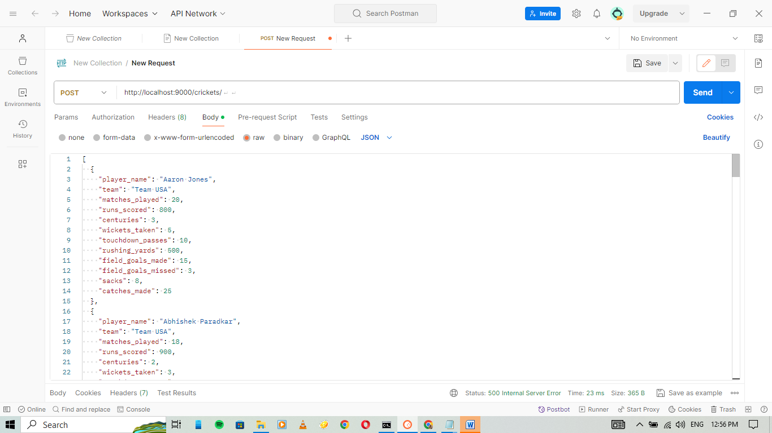

Getting all the Player details

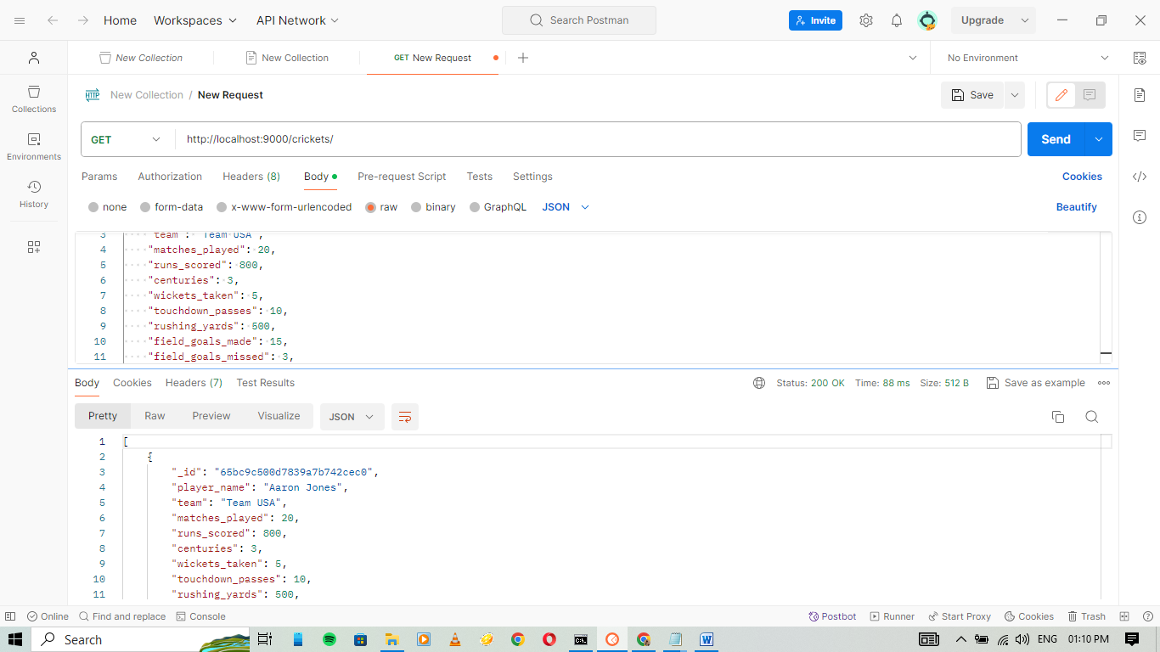

Getting the specific detail of the player by giving the id

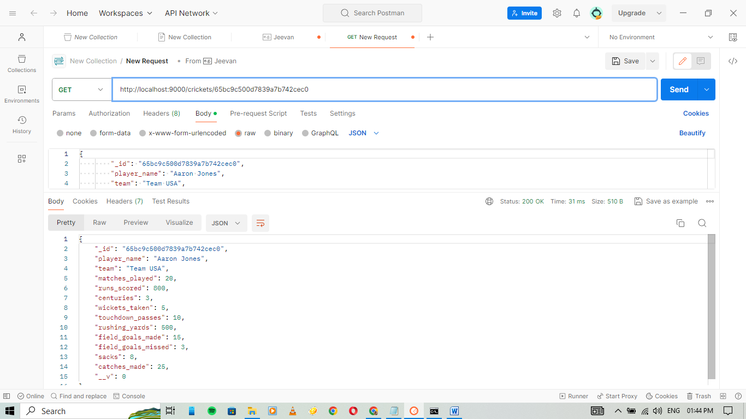

Updating the matches_played by Ali Khan from 20 to 40

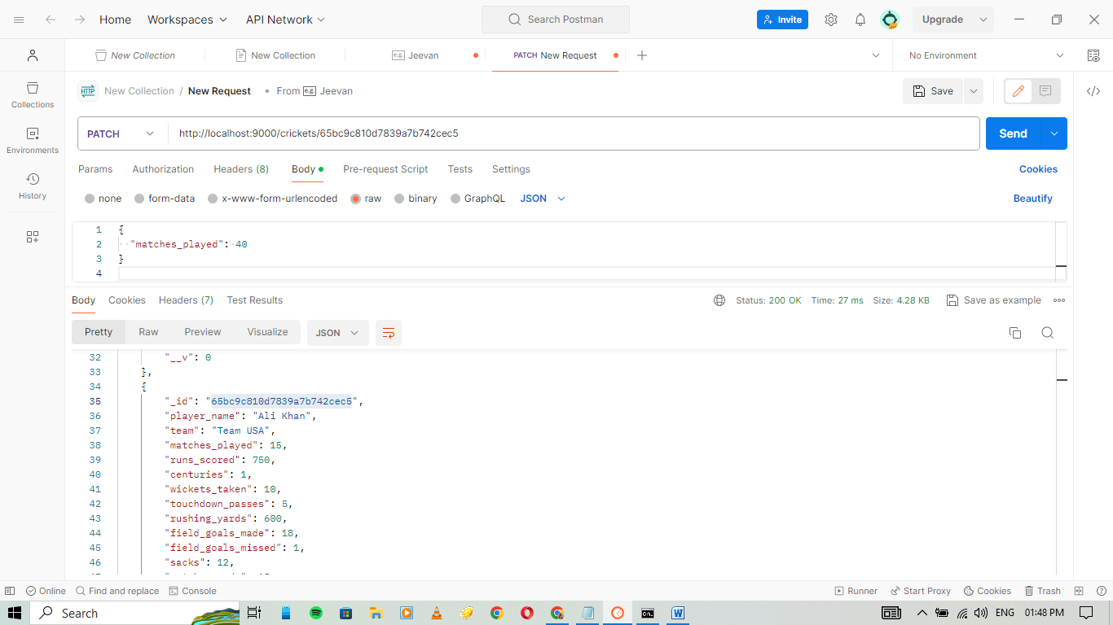

Delete the player details through id

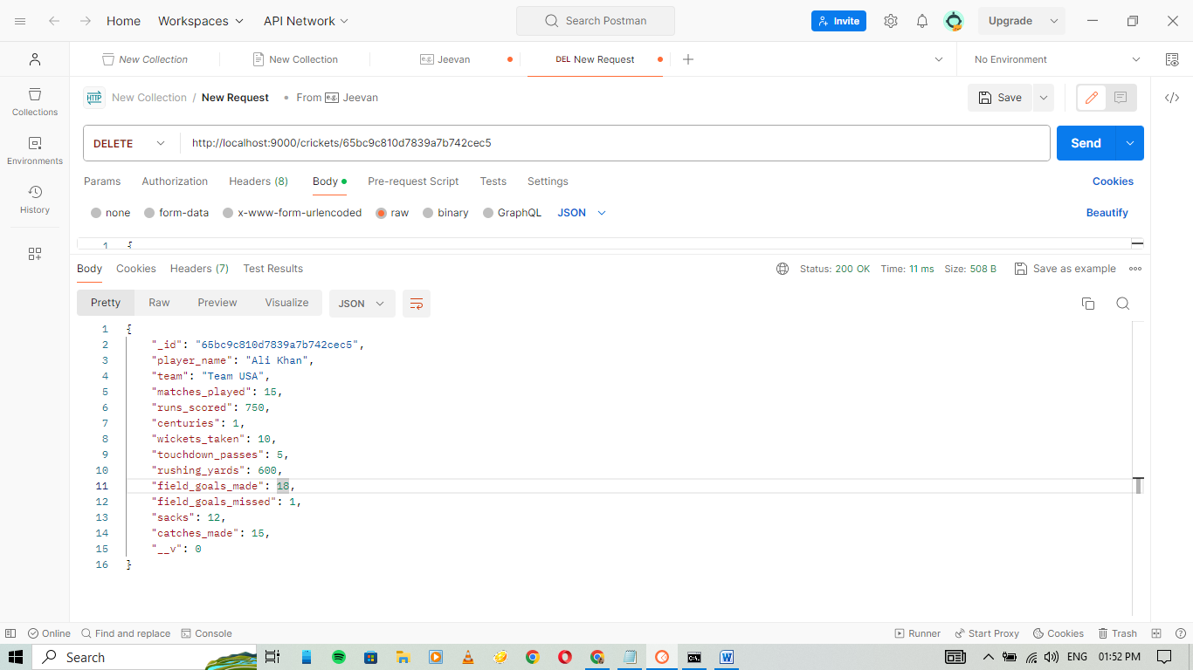

Performing 5 queries

1. **Players with more than 500 runs**

db.Cricket.find({ "runs_scored": { $gt: 500 } })

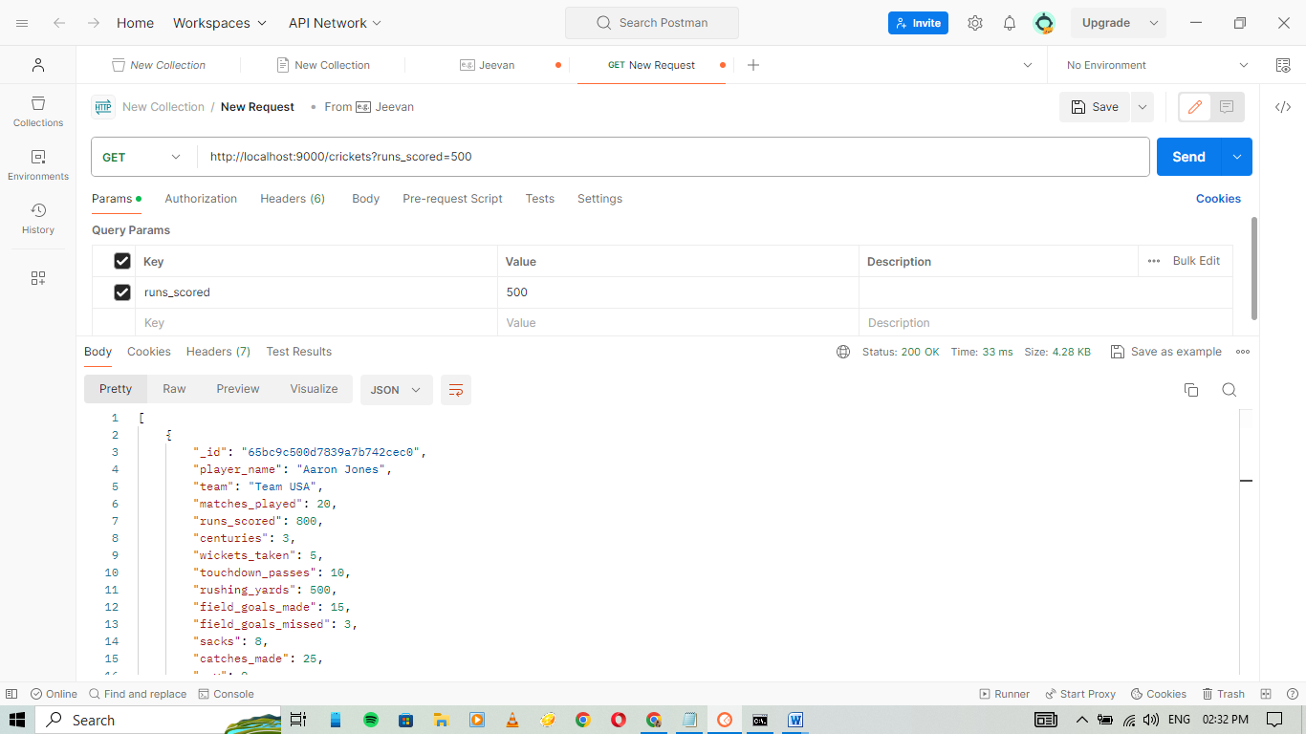

1. **Players who made more than 15 field goals**

db.Cricket.find({ "team": "Team USA", "field_goals_made": { $gt: 15 } })

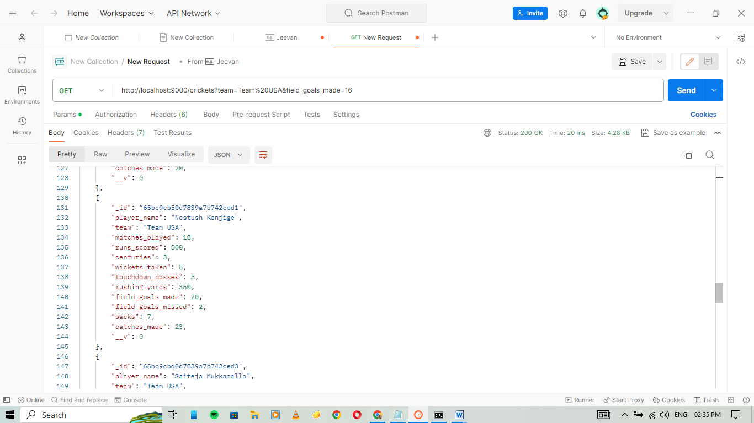

1. **Players with a runs-per-match ratio greater than 40**

db.Cricket.find({ "team": "Team USA", $expr: { $gt: [ { $divide: ["$runs_scored", "$matches_played"] }, 40 ] } })

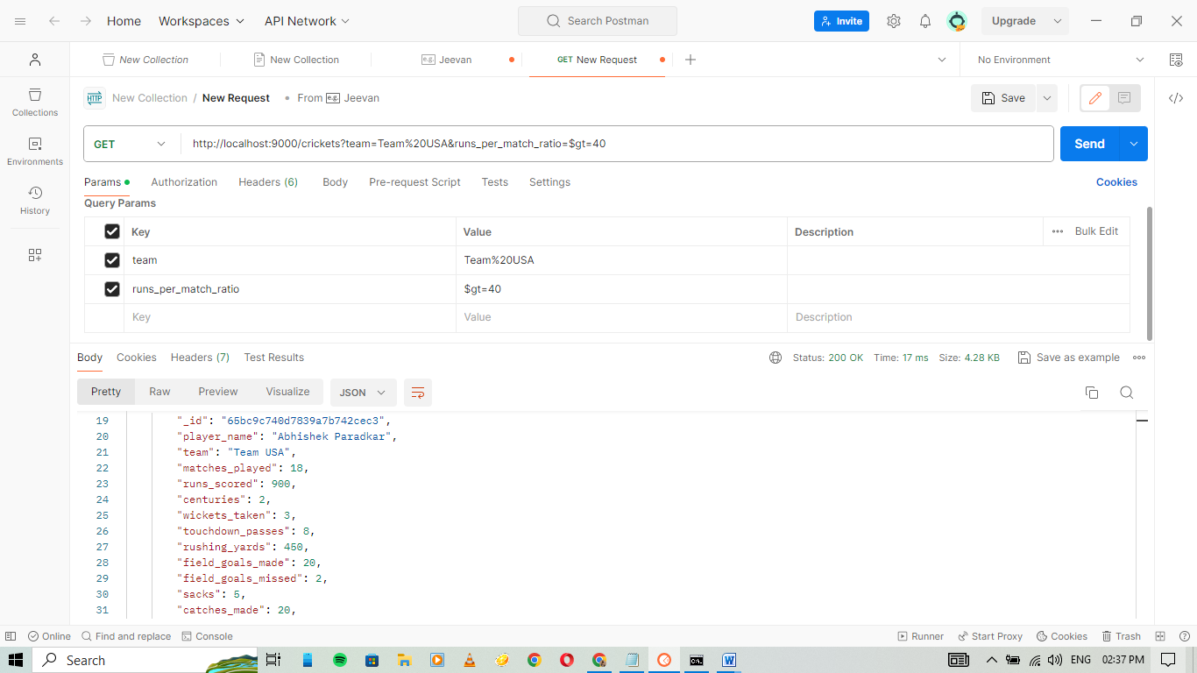

1. **Players who played at least 18 matches and scored more than 700 runs**

db.Cricket.find({ "team": "Team USA", "matches_played": { $gte: 18 }, "runs_scored": { $gt: 700 } })

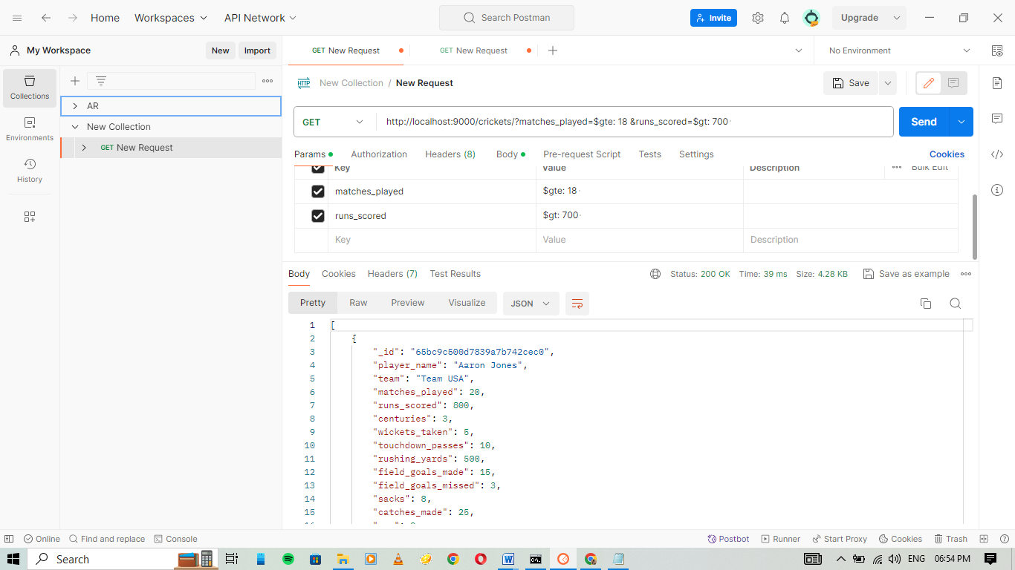

1. **Players with more than 2 centuries and 10 catches**

db.Cricket.find({ "team": "Team USA", "centuries": { $gt: 2 }, "catches_made": { $gt: 10 } })

